Name
Course
Institution
Date
19th Century Impressionism and Post-Impressionism
Since its inception, the world has witnessed different forms and periods of art. In essence, almost every century, different approaches to art have emerged to give unique creations that are inspired by equally distinct approaches. Among the factors that tend to change when a new approach emerges includes the perception towards art, tools employed, technique applied and associated inspirations. One of the periods of and approaches to art that can help best demonstrate this is the 19th century impressionism and post-impressionism. Based on this, this paper will look at two artworks from these periods in the bid to demonstrate and help understand the differences that often characterizes different art and architecture periods and also to have a comprehensive understanding of the impressionism and post-impressionism periods.
To achieve the above it is foremost important to have an overview of what impressionism and post-impressionism entails. Impressionism and post-impressionism period can be described as artistic movements that emerged in the late 19th century in France. Impressionism argued against state-run academies and salons, instead favoring independent exhibitions (Cutting 41). Additionally, impressionists majorly focused on contemporary landscapes and scenes that characterized the modern life in their painting, with special focus on recreation and bourgeois leisure. In their works, they focused on momentary effect of light, movement and atmosphere, an act that was anchored on the desire to capture transitory moments (Cutting 42). Even more, impressionism reiterated three particular approaches that include the stressing of the paint on the canvas’ surface, flattening any sense or angle of perspective by ensuring that tonal modeling was lacking and employing cropped perspectives that were inspired by prints from the Japanese society. It is also worth highlighting that in line with change of approach, impressionists took a different approach from their predecessors by painting in the open air and using a palette characterized by pure colors.
On the other hand, post-impressionism refers to the action and response against impressionism particularly in the 1880s. In essence, the post-impressionism approach rejected the focus by impressionists on spontaneity and naturalistic elevation of light and color (Nicolson 11-12). In contrast, post-impressionists leaned towards the emphasis on increased symbolic content, structure and formal order. However, like impressionists they reiterated the artificiality of the artwork, while they remained of the opinion that color can be separate from form and composition, and still act as the aesthetic and emotional base upon which meaning is derived (Nicolson 12). Regardless of these differences, impressionism and post-impressionism remain prominent and revered like almost any other prominent artistic movement.
The images below offer a depiction of impressionism and post-impressionism. Using the images, one can easily realize the highlighted factors above and the differences between the works of art that help identify them as impressionist and post-impressionist works of art. Figure 1 represents impressionism, while figure two represents post-impressionism.
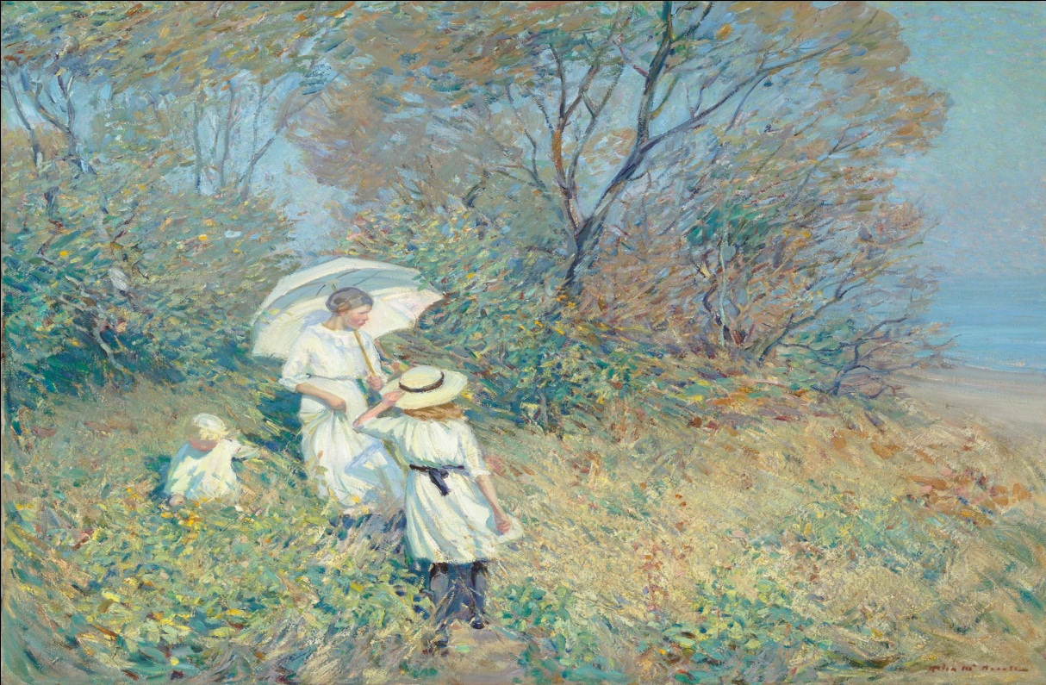
Figure 1: Image highlighting impressionism
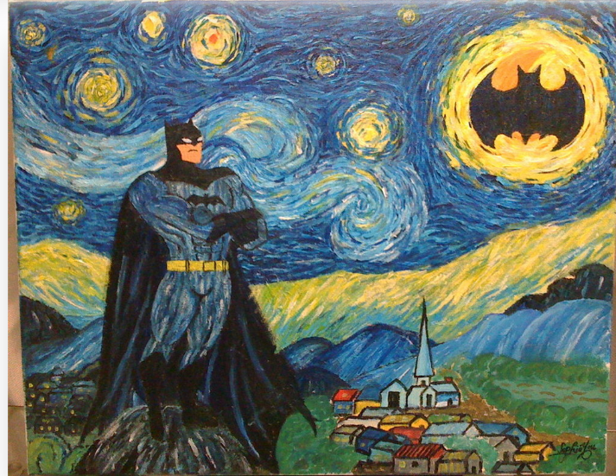
Figure 2: Image showing post-impressionism
From the onset, there is the realization that the two works of art in that figure 1 is focused on contemporary landscapes as well as modern life scenes. In the image, the artist captures a beautiful landscape upon which a family is seen spending their leisure and recreation, which is in line with the impressionism approach. Among the factors that impressionism consider include the ephemeral nature of light, movement and the atmosphere. This is seen in figure 1 where all these factors can be seen. For one, the image captures and makes use of the fleeting light that in turn helps to bring clarity and life to the picture. Even more, there is the realization that light helps to emphasize colors and other necessary details such as the brown patches and grass that one easily notices. When it comes to movement, the image attempts to capture the subjects while they are on the move or certain body parts are on the move. This is seen in how the woman in figure 1 appears to be on the move, with the children are also captured while in motion.
Figure 2, however, emerges to show some form of difference in approach when compared to figure 1. For one, unlike figure one, figure two does not care much about landscapes. Rather, it is majorly focused on certain relatable symbols. For instance, looking at the artwork, there is the realization it tries to present Batman as some form of guardian of the night. This is seen in how he is presented as being over a hill watching over a community down below. An even more interesting symbol can be seen in the posturing of the Batman logo on the sun, which one may reason is a symbol that Batman is the light that watches over people and the guardian of the universe. Color is also a prominent element in the image. It is used to emphasize the significance of different aspects of a given image. However, while there exist differences, both images strive at ensuring superficial works of art.
Considering these factors, it is evident that impressionism and post-impressionism marked a different period of art. In this regard, they remained characterized by different approaches to art including when it comes to focus on the subject matter. Even more, impressionism and post-impressionism differ in their approach to art further emphasizing the fact that different periods in human existence offer equally different inspirations that proceed to influence the approach taken by an individual. For instance, while the former focuses on things such as landscape, the latter focuses more on symbolism. This means that without understanding the artistic movement one can find it challenging identifying the artworks they are associated with.

Works Cited
Cutting, James E. Impressionism and its canon. Lanham, MD: University Press of America, 2006.
Nicolson, Benedict. "Post-Impressionism and Roger Fry." The Burlington Magazine 93.574 (1951): 11-15.

